APRILTAG-BASED
LOCALIZATION
SETUP AND VERIFICATION GUIDE
Build, launch, and pose-verification procedure for the ips localization package
ROS 2 • Overhead Camera • AprilTag
Version 1.0
Date: July 2026

Table of Contents
1. Package Information
2. System Architecture
3. Workspace Setup
4. Build and Run Workflow
5. Verifying Detection
6. Viewing the Detected Pose

1. Package Information
Package name: ips
If the package is provided as a ZIP file:
1. Extract (unzip) the package.
2. Copy the extracted ips package into the src directory of your ROS 2 workspace.

2. System Architecture
The diagram below shows how the overhead camera feed is processed into per-vehicle pose topics.
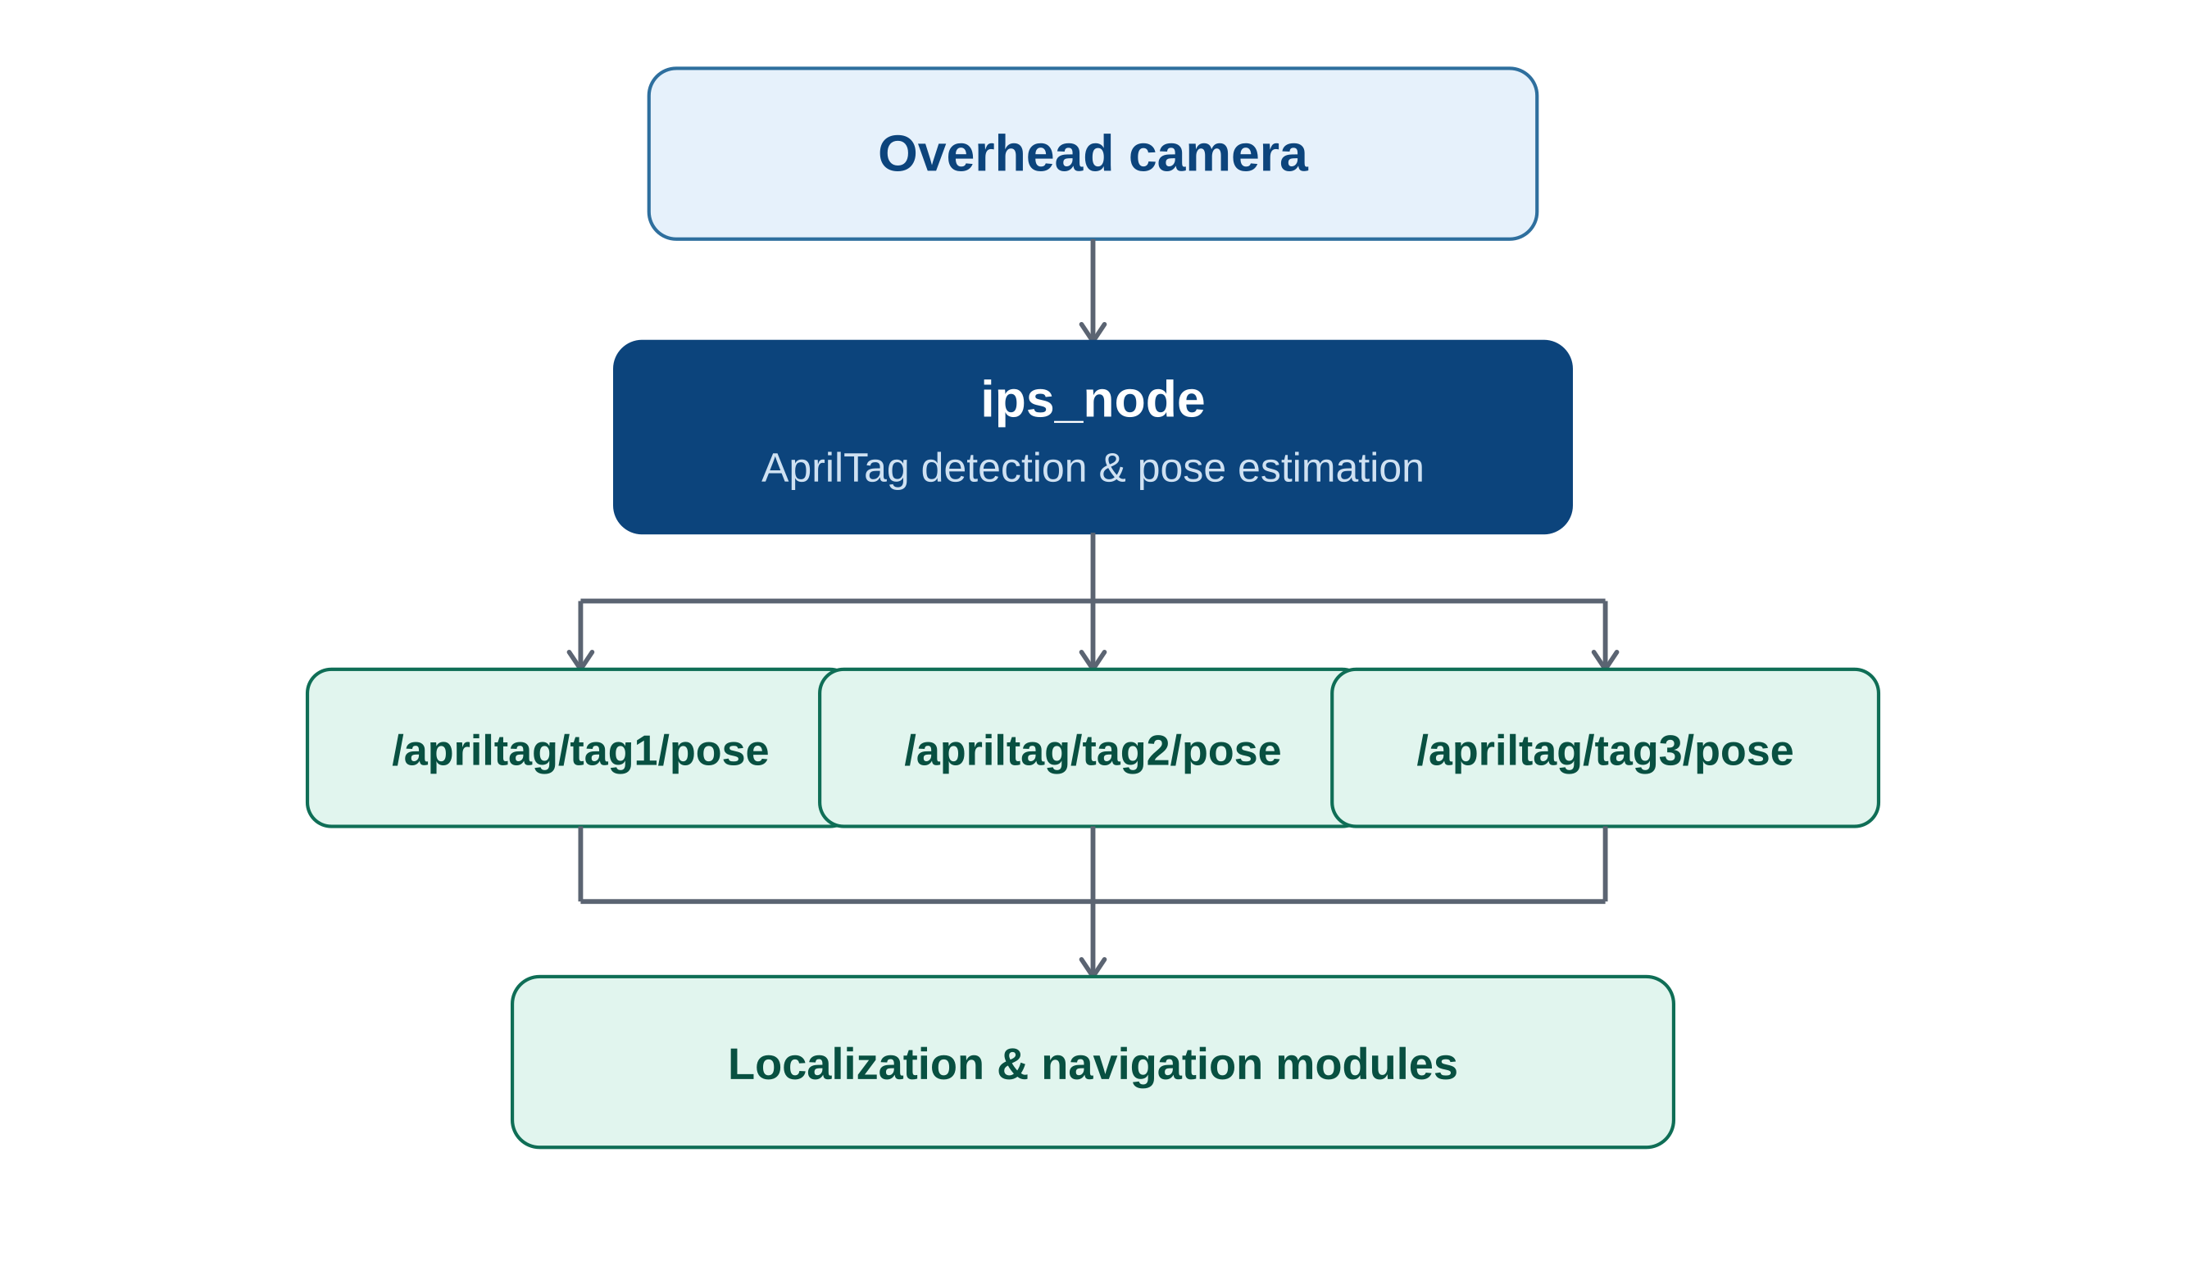
Figure 1 — AprilTag localization system architecture

3. Workspace Setup
If you do not already have a ROS 2 workspace, create one using the following commands:
mkdir -p ~/ros2_ws/src
cd ~/ros2_ws
colcon build
source install/setup.bash
Note: it is recommended to add the following line to your ~/.bashrc so the workspace is sourced automatically whenever a new terminal is opened:
source ~/ros2_ws/install/setup.bash

4. Build and Run Workflow
The diagram below summarizes the full sequence from copying the package to verifying the published pose.
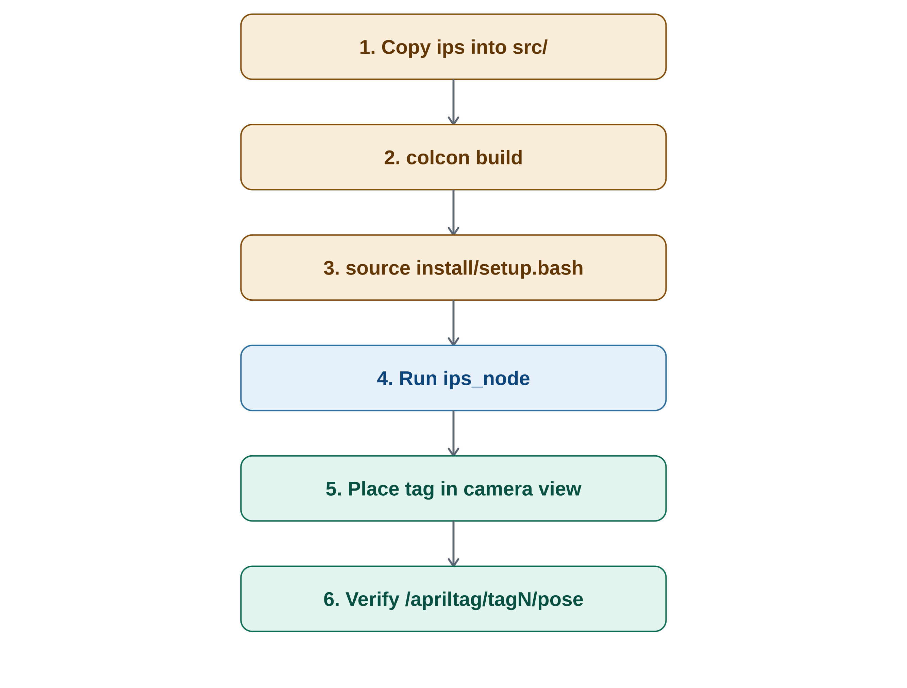
Figure 2 — Setup, build, and verification workflow

Building the Package
After copying the ips package into ~/ros2_ws/src, rebuild the workspace:
cd ~/ros2_ws
colcon build
source install/setup.bash

Running the Localization Node
Launch the AprilTag localization node:
ros2 run ips ips_node

5. Verifying Detection
After starting the node, an output window similar to Figure 3 will appear.
Place the vehicle with the corresponding AprilTag ID within the camera's field of view. Once the tag is detected, the localization system will estimate and display the vehicle's pose.
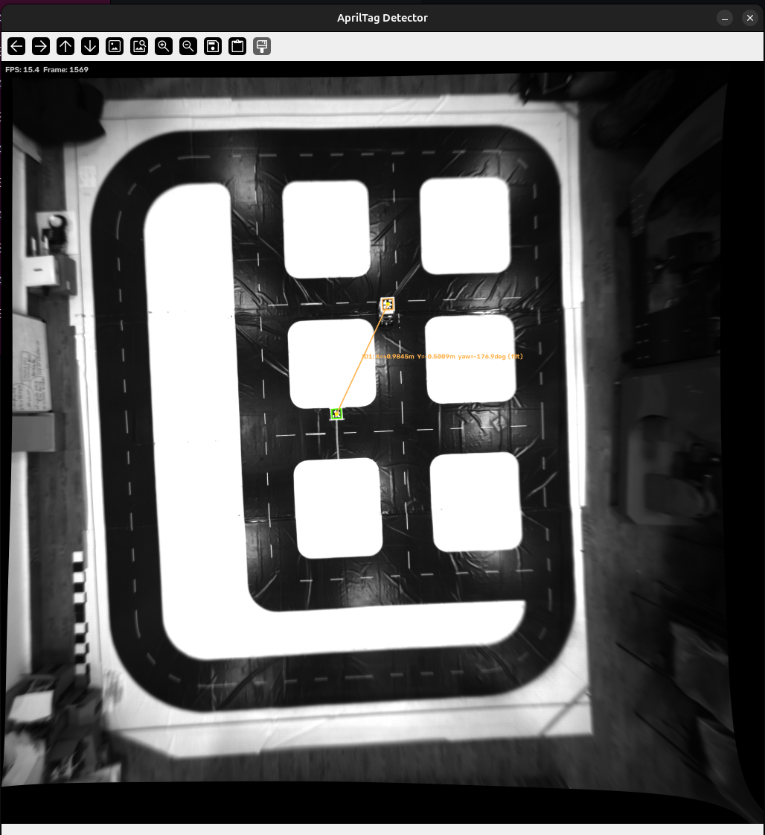
Figure 3 — AprilTag-based localization, live detection view

6. Viewing the Detected Pose
To monitor the estimated pose of a detected tag, use the following command:
Replace the tag number with the actual vehicle's AprilTag ID.
ros2 topic echo /apriltag/tag1/pose
For example:
Vehicle ID | Topic
1 | /apriltag/tag1/pose
2 | /apriltag/tag2/pose
3 | /apriltag/tag3/pose

If the tag is successfully detected, the terminal will continuously publish the pose information, including the tag's position and orientation.

Example output:
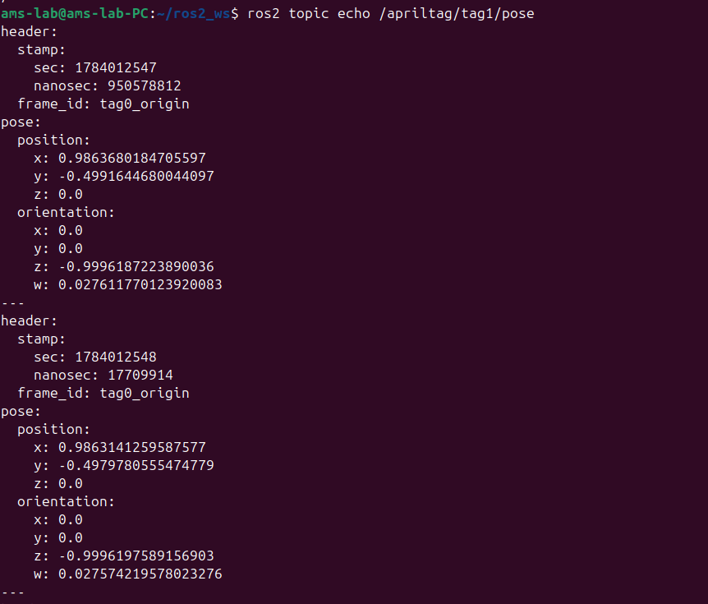
Figure 4 — Estimated pose of a detected tag
This confirms that the AprilTag has been detected successfully and that the localization node is publishing the vehicle's pose.

